**Solution Architecture:**

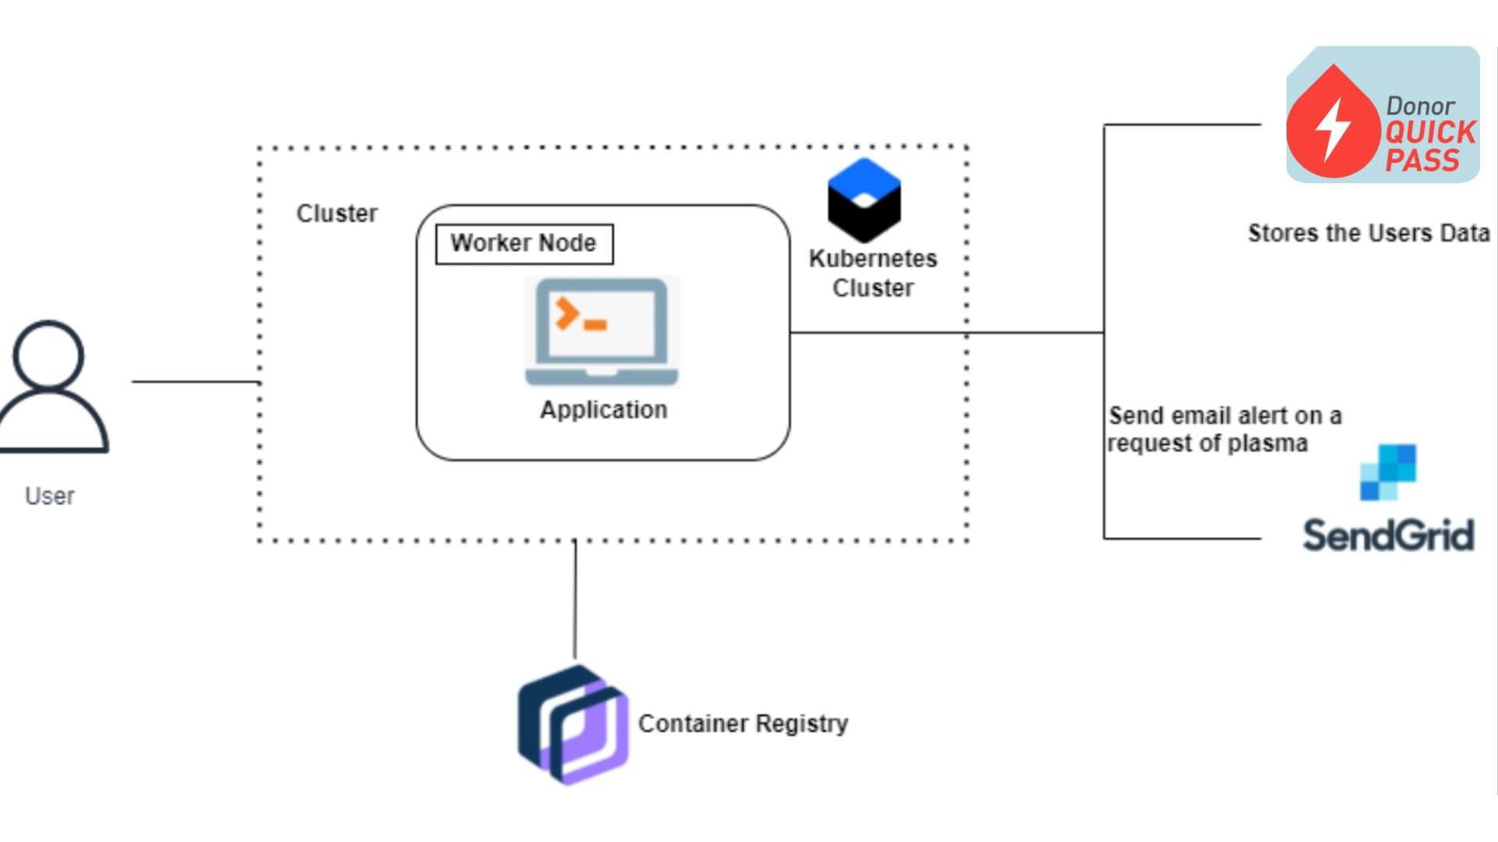

During the COVID 19 crisis, the requirement of plasma became high and the donor count being low. Saving the donor information and helping the need by notifying the current donors would be a helping hand. In regard to the problem faced, an application is to be built which would take the donor details store it and inform them upon a request.

Serverless computing is the current trend in software application development. Microservices are a popular new approach for building maintainable, scalable, cloud-based applications. AWS is the perfect platform for hosting micro-services. In this project, we will be building a plasma donor app with AWS services like lambda functions, API gateway, and DynamoDB.

FLOWCHART:

